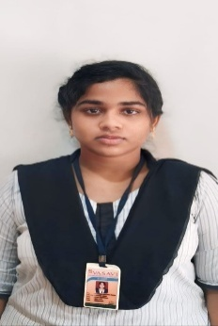
TEAM LEADER

NAME : KOSURI LAKSHMI PRASANNA KUMARI
EMAIL :karumakumarnani182@gmail.com

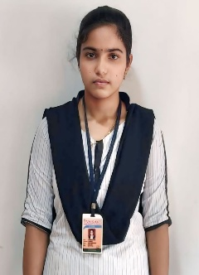
TEAM MEMBER.1
NAME: VANAPALLI ROHINI KALYANI
EMAIL: rohinikalyanichinni@gmail.com

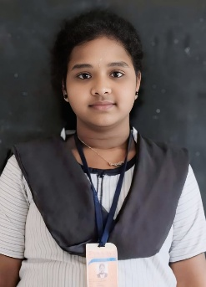
TEAM MEMBER.2
NAME: ATHI NAGA VENKATA DEVIKA
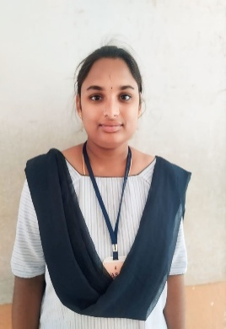
EMAIL: nvdevika@gmasil.com

TEAM MEMBER.3
NAME : EJJADA LAVANYAEMAIL
lavanyaejjada@gmail.com

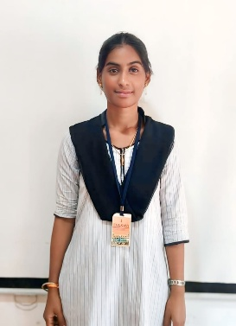
TEAM MEMBER.4
NAME : BOTTA JAYA
EMAIL: jayabotta@gmil.com

